RESILIENCE STRATEGY CARDS
Directions: Each student group should receive all 21 cards. Cut the cards out individually and do not include the category. Mix up the cards and add them to a Ziploc bag for each group to use. You can use an uncut version as a key for wrap up or if there are questions.
Movement and Innovation | Capturing and Storage | Efficiency and Reuse
MIGRATION: Migrate to follow seasonal water sources. | RAIN HARVESTING: Use rainwater harvesting techniques to trap rainwater as it falls.  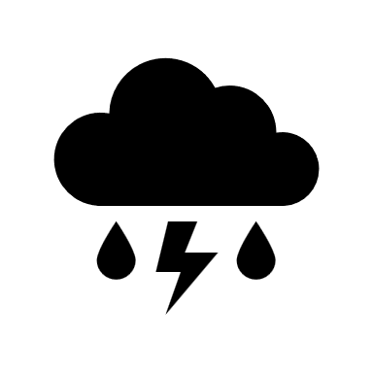 | MORE EFFICIENT APPLIANCES: Encourage buying appliances that use less water.
RECYCLING: Use water recycling technology at sewage treatment plants  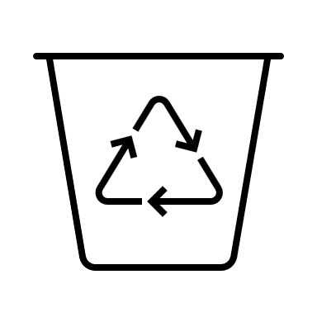 | EARTHWORKS: Dig earthworks like basins and berms to stop water from running off the site | COMPOSTING TOILETS: Encourage composting toilets that do not use water
MORE EFFICIENT TECHNOLOGY: Develop appliances that use less water | REUSE: Find a way to clean and reuse water that makes its way into storm drains | IRRIGATION: Use more efficient irrigation  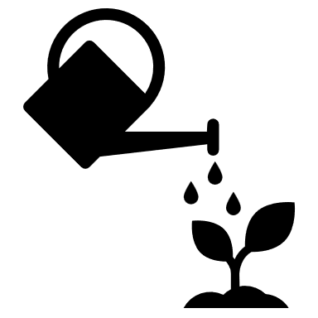

Movement and Innovation | Capturing and Storage | Efficiency and Reuse
DESALINIZATION Desalinate (remove salt) from seawater and transport it to arid lands.  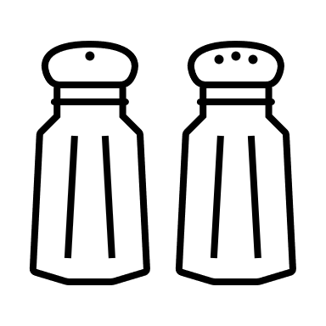 | ROAD WORKS: Put curb cuts and basins along roads to absorb more water. | RECYCLING: Recycle wastewater by cleaning it and recharging it back into the ground.  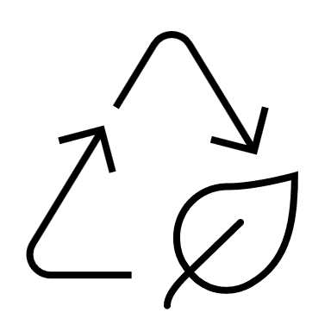
PERMEABLE PAVEMENT: Pave roads with materials like permeable concrete that allows water to get to the soil underneath. | MOUNDS: Dig mounds around plant crops to trap rainwater. | ENFORCEMENT: Encourage laws that discourage high water use like lawns and golf courses.
CROPS: Use crop varieties that use less water and are adapted to arid lands. | WATER: Find newer sources of groundwater. | PLANTS: Plant native vegetation that uses less water.
POLLUTION: Reduce pollution that occurs on streets so rainwater is not contaminated.  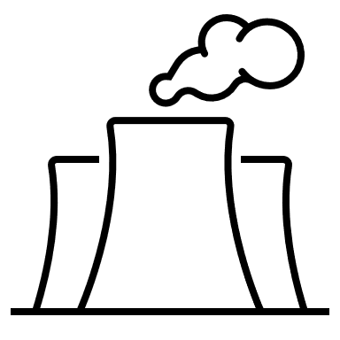 | 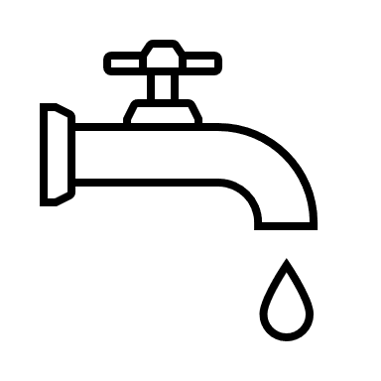  LESS USAGE: Use less water from surface water sources. | COST: Raise the price of water so it costs more to use.

